CERTIFICATE

confirming participation in
IX INTERNATIONAL MUSIC COMPETITION – Belgrade, Serbia 2018

The competition is organized and held by the Association of pedagogues musical institutions of Serbia and production centre MIR production, with the support of public institutions of culture and communication.

(тeacher fills up)
Competitor | Teacher | Discipline,  Category | Prize, Points | Musical institution | City,  Country

JURY for discipline … (тeacher fills up)

Competition takes place on 34 nominations (all classical and national instruments- solo, dues, ensembles, orchestras and choirs). In the contest in 2018, was attended by 800 online applications, 34 countries, which is 1179 contestants and 170 cities from 260 schools!

The jury was attended by 78 musicians from 23 countries many of whom are eminent teachers, musicians and artists who teach at prestigious music institutions are soloists and play in the top 10 best orchestras and opera houses.

Since its inception in 2010 to 2018 in competition competed more than 8,000 participants from 44 countries, 537 cities and who played on more than 900 musical institutions.

The total number of video views on www.musiccompetition.eu exceeded 7,5 million! According to these indicators INTERNATIONAL MUSIC COMPETITION - Belgrade, Serbia became one of the leaders among the international music competitions in the world!

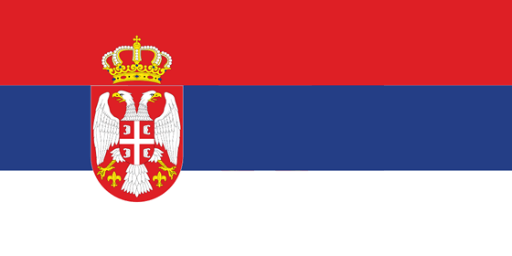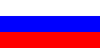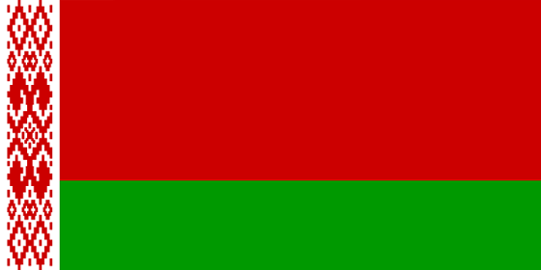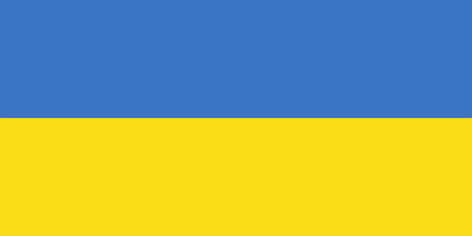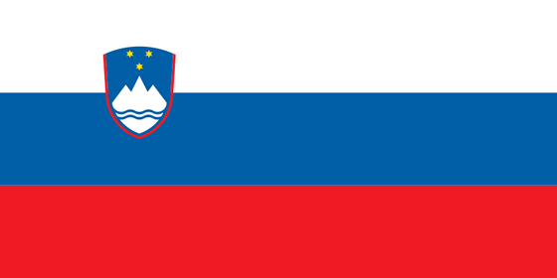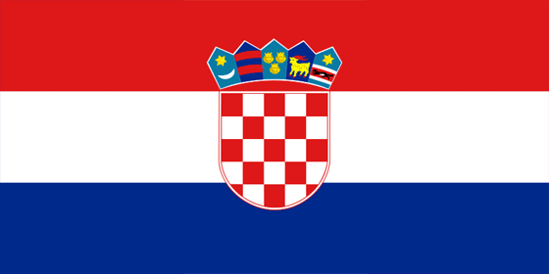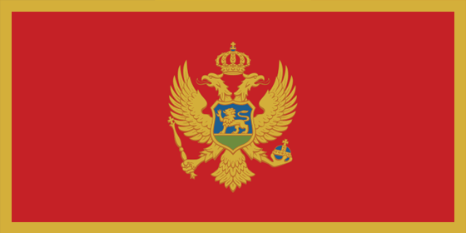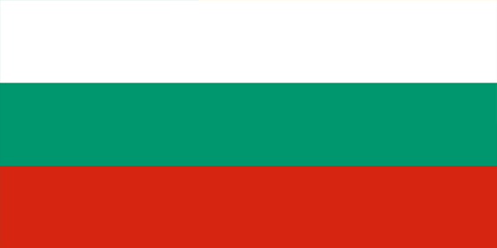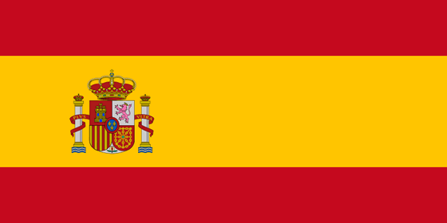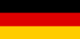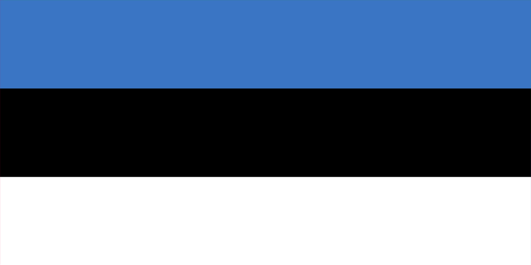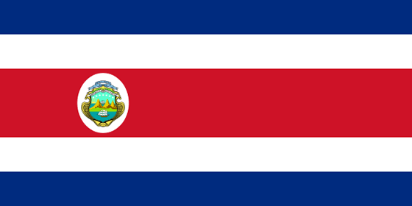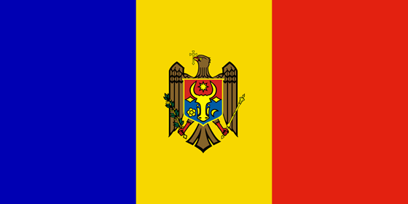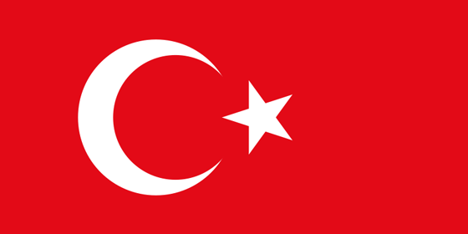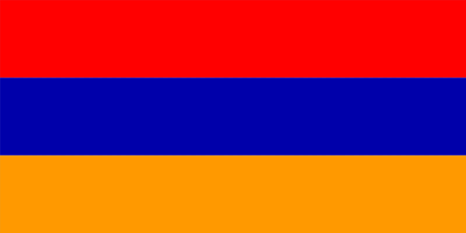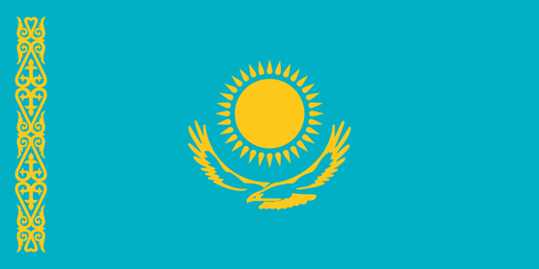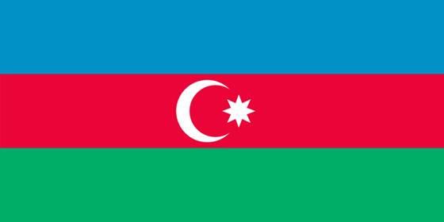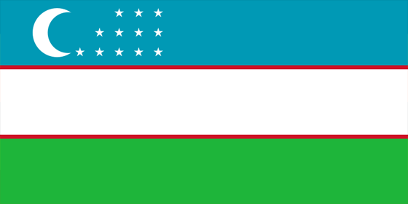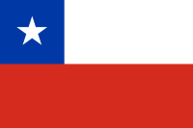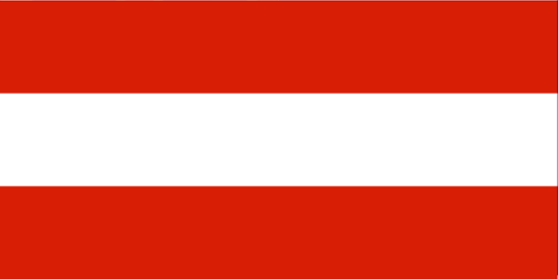…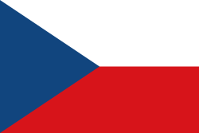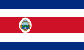

Serbia, Russia, Belorussia, Ukraine, Croatia, Slovenia, Montenegro, Macedonia, Bulgary, Spain, Slovakia, Belgium, Germany, Poland, Estonia, Costa Rica, Moldavia, Turkey, China, Armenia, Romania, Kazakhstan, Azerbaijan, Uzbekistan, Bosnia and Herzegovina, Austria, Mongolia, Norway, Italy, South Korea, Chile, Hungary, Hong kong, France

This certificate is for

(тeacher fills up)

and confirms the participation in
IX International Music Competition
Belgrade, Serbia 2018

Serbia, Belgrade, President of Association
May 9, 2018 Milomir Dojcinovic

