CERTIFICATE

confirming participation in IX INTERNATIONAL MUSIC COMPETITION
Belgrade, Serbia 2018

The competition is organized and held by the Association of pedagogues musical institutions of Serbia and production centre MIR production, with the support of public institutions of culture and communication. The competition is organized by a professional association (Association of pedagogues musical institutions of Serbia), research or educational institution that performs competitions in the field of competition

Competition is conducted for the Elementary Music School, High Music School and University students. The competition rules for all instruments are published on vvv.musiccompetition.eu.eu at least 6 months before the start of the competition.

Competition is conducted for the Elementary Music School, High Music School and University students.

(тeacher fills up)
Competitor | Teacher | Discipline,  Category | Prize, Points | Musical institution | City,  Country

In the category PIANO performed 240 competitors. There were 24 different countries (Russia, Poland, Ukraine, Qatar, Slovenia, Costa Rica, Macedonia, Belarus, Israel, China, Romania, Checz, Bulgaria, Kazakhstan, France, Turkey, Serbia, Moldova, Germany, Armenia, Uzbekistan, Mongolia, Spain) present in the competition for PIANO.

Competitors in the PIANO category were evaluated by an international jury from 5 countries (Russia, Serbia, Israel, France, Germany):

1. Rimma Bolshakova Novosibirsk, Russia Special Music High School
2. Goara Lazic Sabac - Šabac, Serbia Music High School
3. Michael Kravtchin - Casel, Germany Musik akademie der Stadt Kassel „LouisSpohr“
4. Helene Berger - Paris, France Directrice artistique Cap Ferret Music Festival
5. Natasha Mitrovic - Belgrade, Serbia Faculty of Music
6. Tamara Yusman (reserve) Ashkelon, Israel Municipal Conservatory of Ashkelon

Competition takes place on 34 nominations (all classical and national instruments- solo, dues, ensembles, orchestras and choirs). In the contest in 2018, was attended by 800 online applications, 34 countries, which is 1179 contestants and 170 cities from 260 schools!

The jury was attended by 75 musicians from 23 countries many of whom are eminent teachers, musicians and artists who teach at prestigious music institutions are soloists and play in the top 10 best orchestras and opera houses.

Since its inception in 2010 to 2018 in competition competed more than 8,000 participants from 44 countries, 537 cities and who played on more than 900 musical institutions.

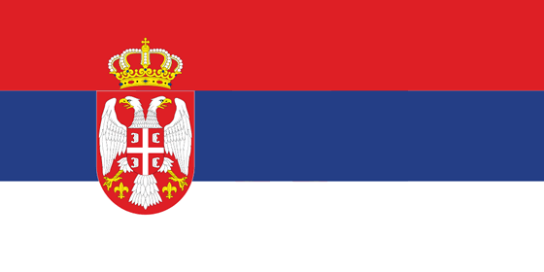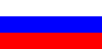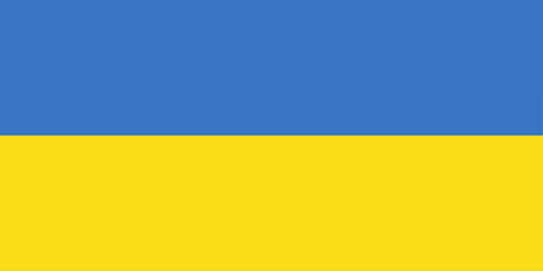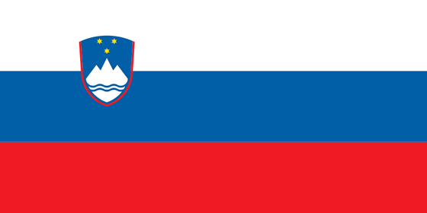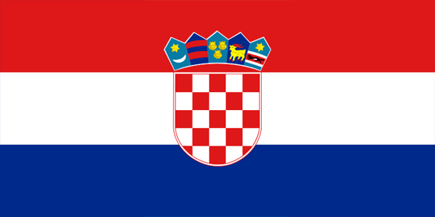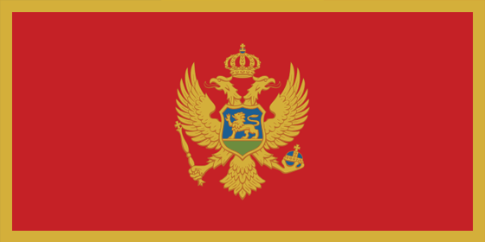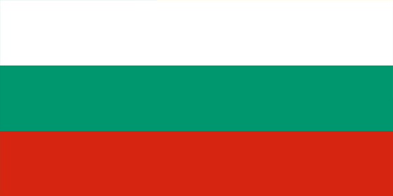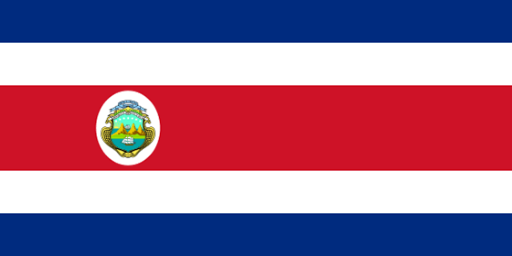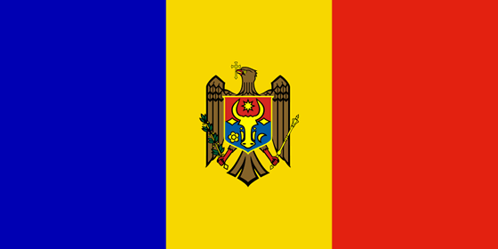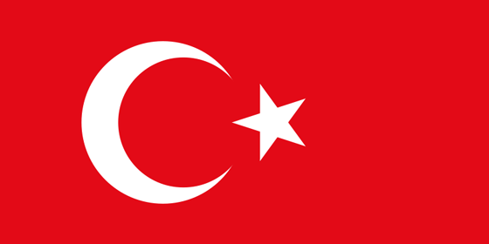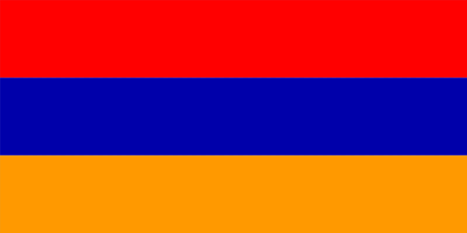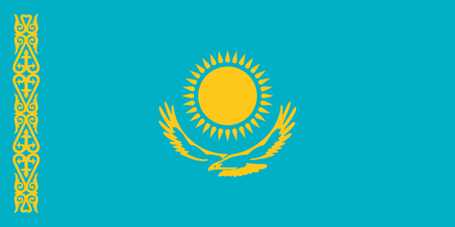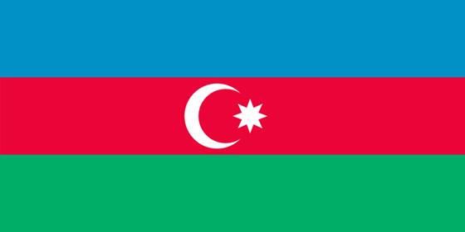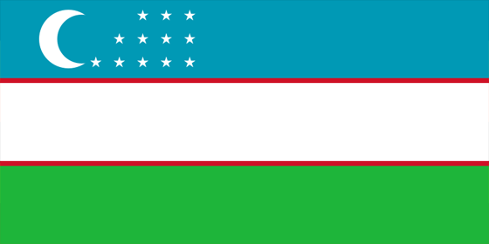…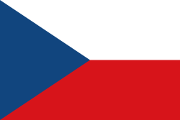
Serbia, Russia, Belorussia, Ukraine, Croatia, Slovenia, Montenegro, Macedonia, Bulgary, Spain, Slovakia, Belgium, Germany, Poland, Estonia, Costa Rica, Moldavia, Turkey, China, Armenia, Romania, Kazakhstan, Azerbaijan, Uzbekistan, Bosnia and Herzegovina, Austria, Mongolia, Norway, Italy, South Korea, Chile, Hungary, Hong kong, Vietnam, France

This certificate is for

(тeacher fills up)

and confirms the participation in

IX International Music Competition - Belgrade, Serbia 2018

Details related to INTERNATIONAL MUSIC COMPETITION – Belgrade, Serbia (competitive video recording, results of the jury) can be viewed at www.musiccompetition.eu

Serbia, Belgrade, President of Association
May 9, 2018 Milomir Dojcinovic

