CERTIFICATE

confirming participation in IX INTERNATIONAL MUSIC COMPETITION
Belgrade, Serbia 2018

The competition is organized and held by the Association of pedagogues musical institutions of Serbia and production centre MIR production, with the support of public institutions of culture and communication.

Competition is conducted for the Elementary Music School, High Music School and University students.

(тeacher fills up)
Competitor | Teacher | Discipline | Prize, Points | Musical institution | City,  Country

In the category GUITAR performed 31 competitors. There were 13 different countries (Russia, Poland, Ukraine, Slovenia, United States, Armenia, Belarus, Serbia, Romania, Belarus, Montenegro, Georgia, Bulgaria).present in the competition for GUITAR.

Competitors in the GUITAR category were evaluated by an international jury from 4 countries (Russia, Argentina, Poland, France):

1. Iwona Bodziak Sanok, Poland The State School of Music
2. Pierre Bibault Paris, France Sevres Conservatory
3. Camilo Verga Buenos Aires, Argentina National Conservatory
4. Tatyana Gracheva (reserve) Saratov, Russia Saratov Sobinov State Academy

Competition takes place on 34 nominations (all classical and national instruments- solo, dues, ensembles, orchestras and choirs). In the contest in 2018, was attended by 800 online applications, 34 countries, which is 1179 contestants and 170 cities from 260 schools!

The jury was attended by 75 musicians from 23 countries many of whom are eminent teachers, musicians and artists who teach at prestigious music institutions are soloists and play in the top 10 best orchestras and opera houses.

Since its inception in 2010 to 2018 in competition competed more than 8,000 participants from 44 countries, 537 cities and who played on more than 900 musical institutions.

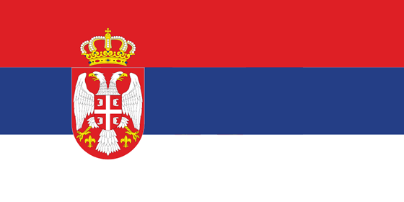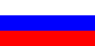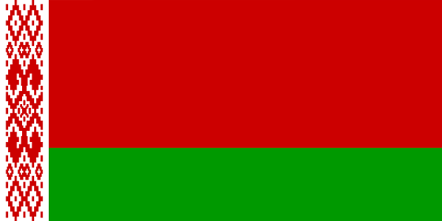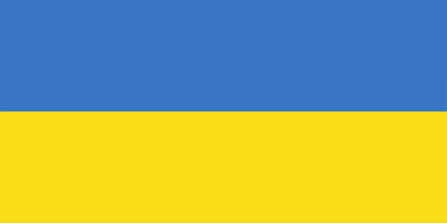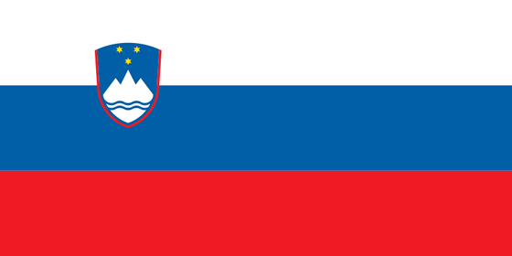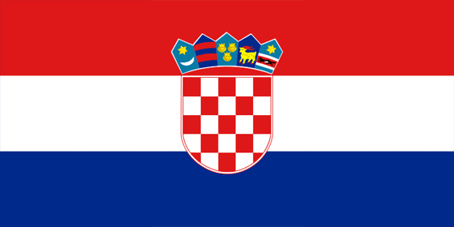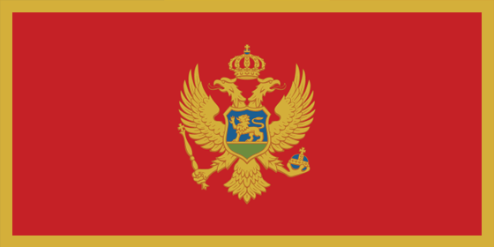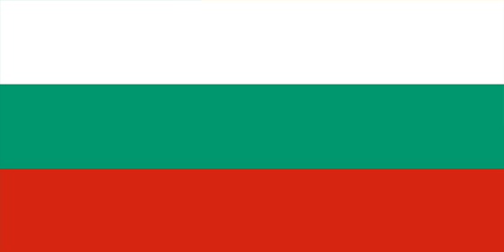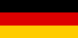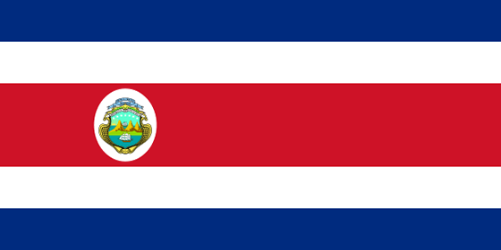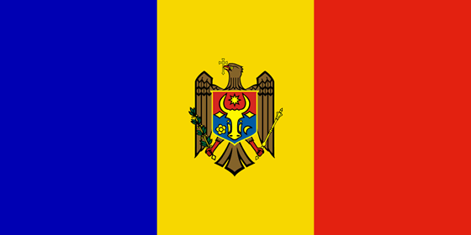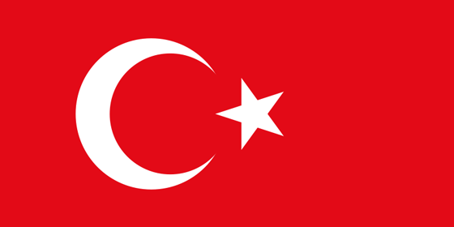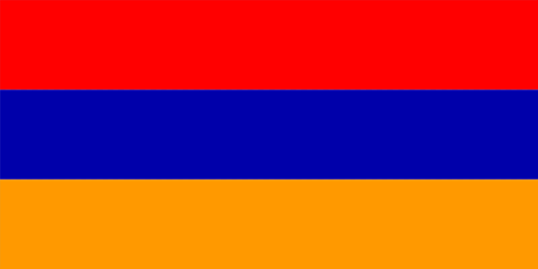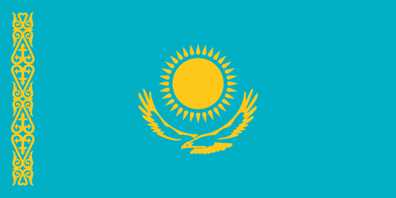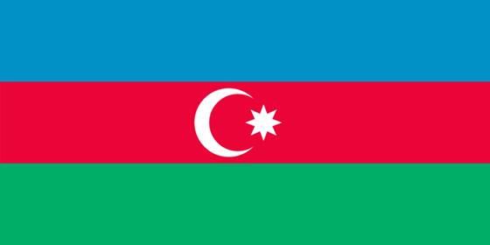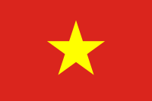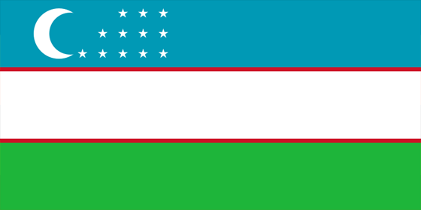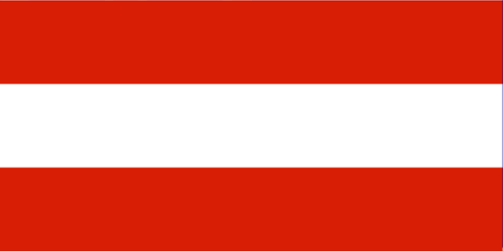…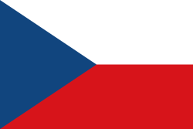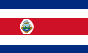

Serbia, Russia, Belorussia, Ukraine, Croatia, Slovenia, Montenegro, Macedonia, Bulgary, Spain, Slovakia, Belgium, Germany, Poland, Estonia, Costa Rica, Moldavia, Turkey, China, Armenia, Romania, Kazakhstan, Azerbaijan, Uzbekistan, Bosnia and Herzegovina, Austria, Mongolia, Norway, Italy, South Korea, Chile, Hungary, Hong kong, Vietnam, France

This certificate is for

(тeacher fills up)

and confirms the participation in

IX International Music Competition - Belgrade, Serbia 2018

Details related to INTERNATIONAL MUSIC COMPETITION – Belgrade, Serbia (competitive video recording, results of the jury) can be viewed at www.musiccompetition.eu

Serbia, Belgrade, President of Association
May 9, 2018 Milomir Dojcinovic

