CERTIFICATE

confirming participation in IX INTERNATIONAL MUSIC COMPETITION
Belgrade, Serbia 2018

The competition is organized and held by the Association of pedagogues musical institutions of Serbia and production centre MIR production, with the support of public institutions of culture and communication.

Competition is conducted for the Elementary Music School, High Music School and University students.

(тeacher fills up)
Competitor | Teacher | Discipline,  Category | Prize, Points | Musical institution | City,  Country

In the category ACCORDION/BAYAN performed 80 competitors. There were 8 different countries (Russia, Poland, Ukraine, Latvia, Belarus, Serbia, Croatia, Norway) present in the competition for ACCORDION/BAYAN.

Competitors in the ACCORDION / BAYAN category were evaluated by an international jury from 5 countries (Finland, Poland, Serbia, Russia, Vietnam):

1. Petri Makkonen Kuopio, Finland Kuopio Concervatoire
2. Andrzej Smolik Sanok, Poland The State School of Music in Sanok
3. Gvozden Erakovic Smederevo, Serbia Music High School “Kosta Manojlovic”
4. Vladimir Grachev Saratov, Russia Saratov Sobinov State Academy
5. Nguyen Tai Hung Hanoi, Vietnam Vietnam National Academy of Music

Competition takes place on 34 nominations (all classical and national instruments- solo, dues, ensembles, orchestras and choirs). In the contest in 2018, was attended by 800 online applications, 34 countries, which is 1179 contestants and 170 cities from 260 schools!

The jury was attended by 78 musicians from 23 countries many of whom are eminent teachers, musicians and artists who teach at prestigious music institutions are soloists and play in the top 10 best orchestras and opera houses.

Since its inception in 2010 to 2018 in competition competed more than 8,000 participants from 44 countries, 537 cities and who played on more than 900 musical institutions.

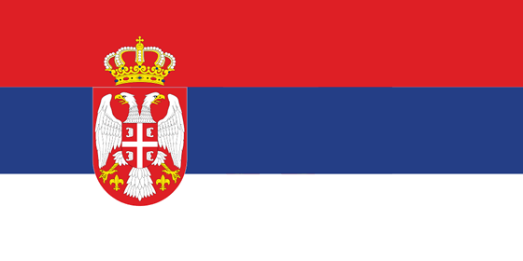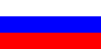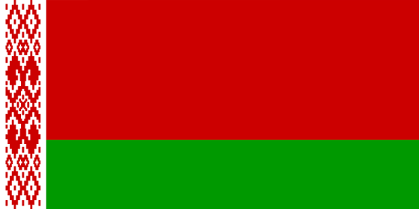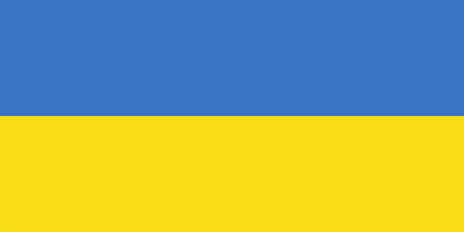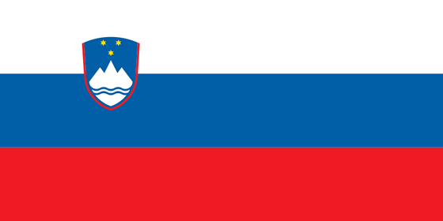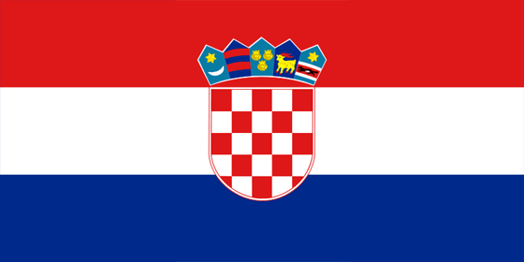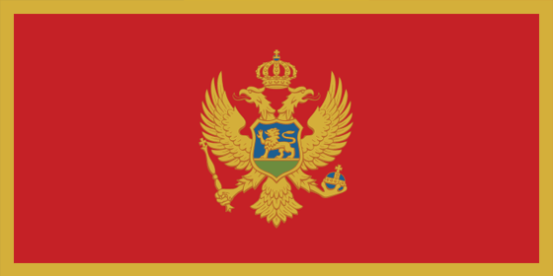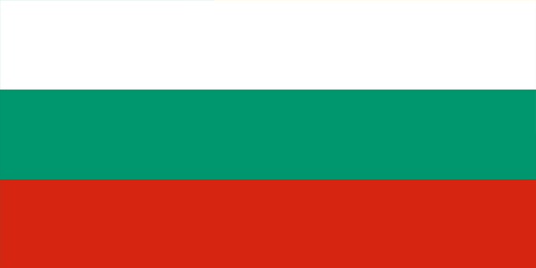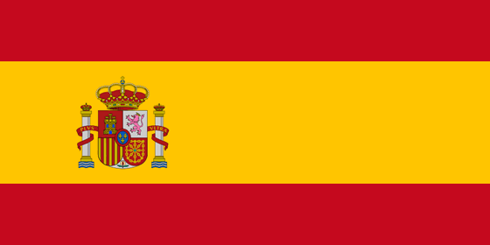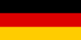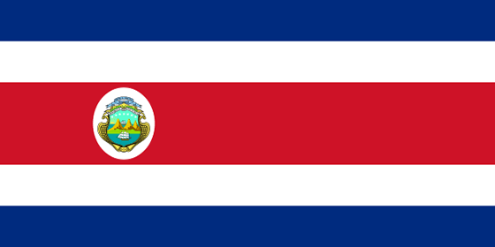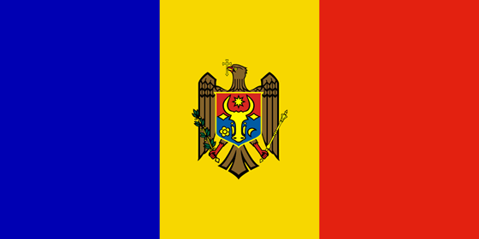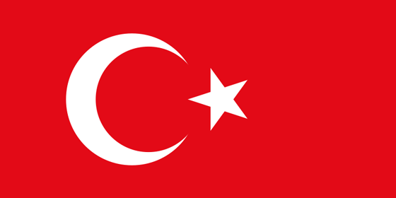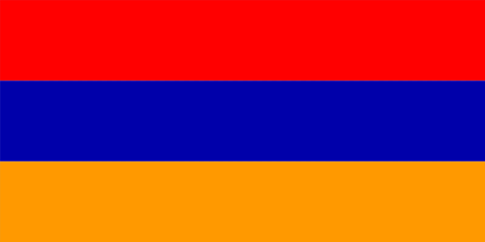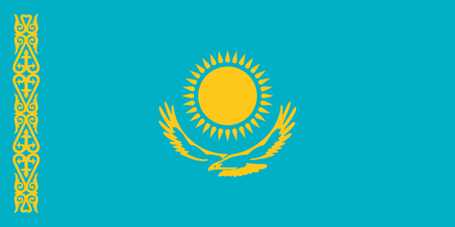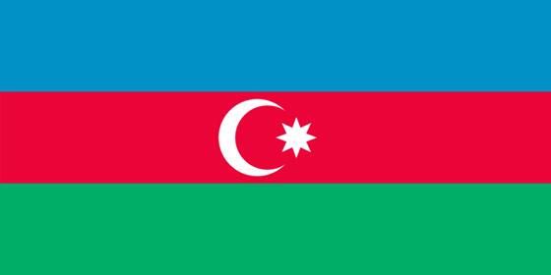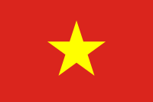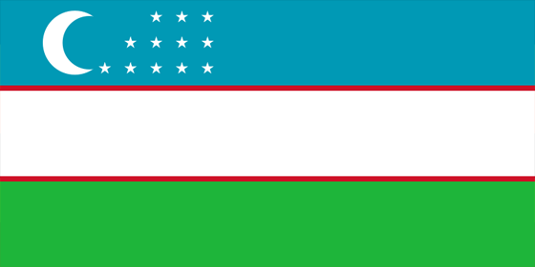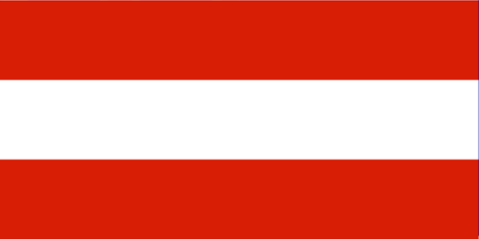…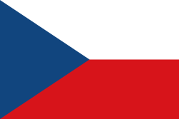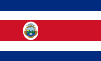
Serbia, Russia, Belorussia, Ukraine, Croatia, Slovenia, Montenegro, Macedonia, Bulgary, Spain, Slovakia, Belgium, Germany, Poland, Estonia, Costa Rica, Moldavia, Turkey, China, Armenia, Romania, Kazakhstan, Azerbaijan, Uzbekistan, Bosnia and Herzegovina, Austria, Mongolia, Norway, Italy, South Korea, Chile, Hungary, Hong kong, Vietnam, France

This certificate is for

(тeacher fills up)

and confirms the participation in

IX International Music Competition
Belgrade, Serbia 2018

Details related to INTERNATIONAL MUSIC COMPETITION – Belgrade, Serbia (competitive video recording, results of the jury) can be viewed at www.musiccompetition.eu

Serbia, Belgrade, President of Association
May 9, 2018 Milomir Dojcinovic

